SOP for handling dataset release
Document Owner | Aina Jené - CEGA Operations Manager (CRG)
Contributors | Name(s) - Role(s)/Title(s)
Version | 1.0
Effective date | DD-MM-YYYY
Approvals | Name(s)
Next revision due | DD-MM-YYYY

Purpose
With the launch of the new services, users must now specify an expected release date for their datasets. However, it's important to note that this release date may not always remain accurate or may have changed since its initial setting.

To ensure the utmost precision and alignment with users’ intentions, we continue to rely on user confirmation before proceeding with any dataset release. This confirmation step acts as a final checkpoint, ensuring that the release aligns perfectly with your current requirements. Your input in this regard greatly assists us in providing a seamless and tailored service.

Scope
This document aims to provide the EGA Helpdesk team with a comprehensive understanding of when to release datasets using the Helpdesk Portal.

Procedure
Diagram for Helpdesk (AFTER SUBMISSION)

Datasets pending to be released with RT ticket

If you have taken an RT ticket requesting to release a dataset, please, follow these steps:
- Check the dataset ID.
  - If the ID(s) is assigned at EBI (EGAD000…) then follow this SOP for sequencing datasets, or this other SOP for array datasets.
  - If the ID(s) is assigned at CRG (EGAD500…) then continue with step 2
- Log in to the Helpdesk Portal and go to “DATASET RELEASE”
- Look for the dataset ID(s) provided in the RT ticket. You can filter the results in the table using control+F / command+F.
- Once you find the dataset(s), check the following information:
  - Title + description is correct (same criteria as this SOP)
  - The request in RT comes from the submitter in the Helpdesk Portal (column name: Submitter)
  - All files are archived (in green)
    - In case that there is one or more files pending to be archived (in grey) set a reminder and check the status of the files in 24 hours.
    - If after 24 hours the file is still pending, create a CRG JIRA ticket and inform the CRG dev team.
  - The submitter is the same as the open RT ticket. If not, we need a written confirmation from the submitter through the RT ticket.
- Once all the information is correct, select them by clicking on the checkbox on the first column.
- Click the release button at the bottom of the table
- Check if the study release worked by going to the EGA website
  - https://ega-archive.org/datasets/{datasetID}
  - If the dataset is available on the website proceed to reply to the RT ticket using RT Article 871.
  - If the dataset is not available on the website, create a CRG JIRA ticket to the dev team (Sabela) , so they can have a look at the issue. You can use the EC project for this issue.
- In the dataset webpage, check if the Access Policy section is completed. Otherwise inform the user that the policy is publicly available and ask to improve it.

Datasets pending to be released with no RT ticket
For those users that set an expected release date but did not created an RT ticket
- Log in to the Helpdesk Portal and go to “DATASET RELEASE”
- Pick the oldest “expected release date” (column name: Expected Release Date) and extract the info of the submitter (column name: Submitter)

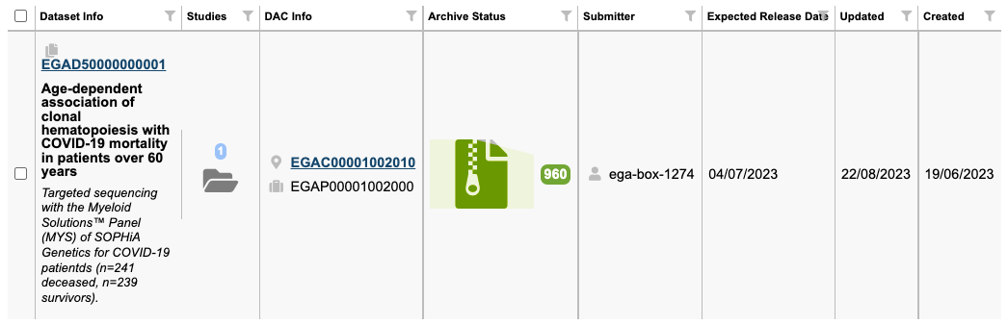

- Check the following information of your selected dataset:
  - Title + description is correct (same criteria as this SOP)
  - The request in RT comes from the submitter in the Helpdesk Portal (column name: Submitter)
  - All files are archived (in green)
    - In case that there is one or more files pending to be archived (in grey) set a reminder and check the status of the files in 24 hours.
    - If after 24 hours the file is still pending, create a CRG JIRA ticket and inform the CRG dev team. You can use the EC project.
- Once all the information is correct, look if there is any active RT ticket related to this user and this topic (data deposition)
  - If the submitter is an email account, you can already look for this email in RT
  - If the submitter is a username you can search for the user information in the Helpdesk Portal > Users > Submitter
  - If the submitter is ega-box, you can check for the authorised submitter list in the vault (original documentation when requesting a submission account), ERAPRO (if info available), or in this spreadsheet (for older accounts).

Query in ERAPRO > ERA
SELECT EGA_SUBMISSION_ACCOUNT.DIR_NAME, EGA_SUBMISSION_CONTACT.*
FROM EGA_SUBMISSION_ACCOUNT
JOIN EGA_SUBMISSION_CONTACT ON EGA_SUBMISSION_ACCOUNT.SUBMISSION_ACCOUNT_ID = EGA_SUBMISSION_CONTACT.SUBMISSION_ACCOUNT_ID
WHERE EGA_SUBMISSION_ACCOUNT.DIR_NAME = 'ega-box-1978';

- If there’s an active RT ticket, check with the ticket owner (another Helpdesk officer). The assigned owner of the ticket should then follow the instructions under “Datasets pending to be released with no RT ticket”
- If there’s not an active RT ticket, then create a new ticket in RT using article XXXX (text - part 1).
  - If the submitter confirms the release:
    - Log in to the Helpdesk Portal and go to “DATASET RELEASE”
    - Find the dataset(s), select them by clicking on the checkbox on the first column.
    - Click the release button at the bottom of the table
    - Check if the study release worked by going to the EGA website
      - https://ega-archive.org/datasets/{datasetID}
      - If the dataset is available on the website proceed to reply to the RT ticket using RT Article 871.
      - If the dataset is not available on the website, contact the CRG dev team through slack, so they can have a look at the issue.
  - If the submitter asks for an extension, set a reminder for the new date in the RT ticket and ask the CRG dev team to update the expected release date on the HD Portal
  - If the user does not confirm the release:
    - Follow up with the submitter every week using article XXXX (text - part 2).
    - If the submitter eventually confirms follow instructions 6(a)
    - If the submitter eventually asks for an extension follow instructions 6(b)
    - If the submitter never replies after 4 consecutive weeks, revoke the dataset (currently revoking is not an option. Just inform the HD team, that the dataset release is stalled and resolve the RT ticket).

